**Lesson – 1. Introduction to Machine Learning on Azure**

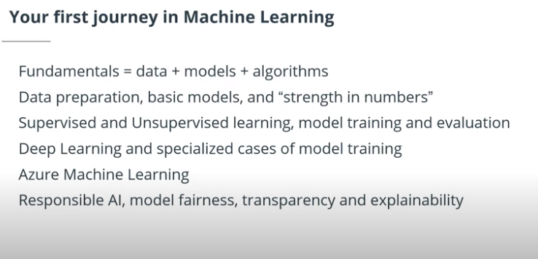

Benefits of Machine Learning -

